**Flipkart Mobile Sales Analysis**

**Analysis Report**

**Session - 2022~2023**

SUBMITTED

BY

**SAMBASIVAREDDY S**

GUIDED

BY

**SHALINI KANAGASABAPATHY**

**Table of contents**

1. Aim

2. Objectives

3. Introduction

4. Research Questions

5. Tools and Datasets used

6. Methodology

7. Observations

8. Conclusion

9. Recommendation

10. References

**Aim:**

The primary aim of our project is to collect and analyze the data to create a

Dashboard on Sales of different Mobiles in Flipkart.

**Objectives:**

Objective of this project is to find out which mobile are most bought and which mobile have highest price. Which features are the factors of buying Mobiles

**Introduction:**

The objective of this project is to analyze Flipkart sales and create an effective dashboard. The Main Scope of this projects is to seeing the analysis report and dashboard, they know that the customers like these things and increase the sales in the future. This project is useful to analyze sales in any industry and increase profits in any industry. MS Excel is used for the Data Cleaning. Tableau Desktop is used to Analyze the Data and Visualize the Data by using Dashboards.

**Reference Questions:**1.Which brand mobile Buys mostly users

2.Which brand mobile has highest cost

3.The processor will effect on buying

4.Which feature will impact on buying of mobile

5.Features impact on buying chart

6.Will rating impact on Buying

7.Customers uses which brand mobile mostly

8. Price after Discount

9.Mobiles for Middle Class People

10.Mobiles for Poor Class People

11.Mobiles for Rich class people

12.Which colour used mostly.

**Tools and Datasets Used:**

* Tableau
* MS Excel
* Dataset Source – Kaggle

Dataset Used

**Methodology:**

**Step 1: Data Collection:**

The dataset was searched and downloaded from the Kaggle website.

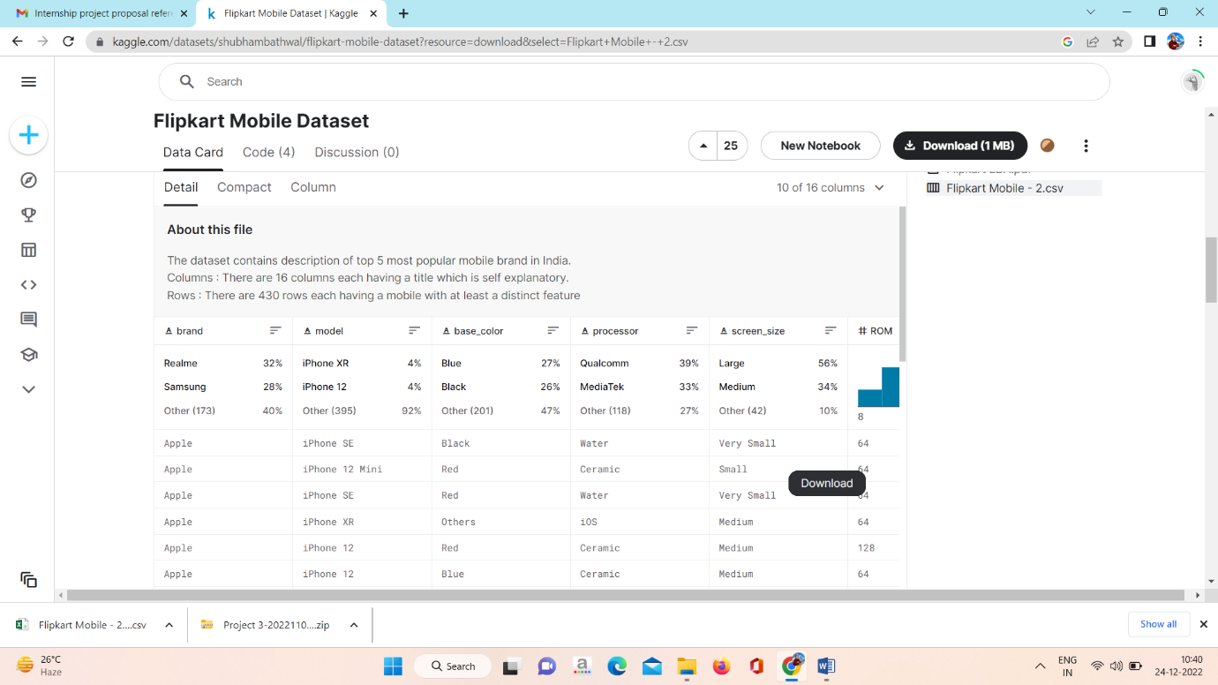

**Step 2: Data Investigation**

The downloaded dataset is checked for any null values and outliers in it. Then done data cleaning and finalized the dataset for the project.

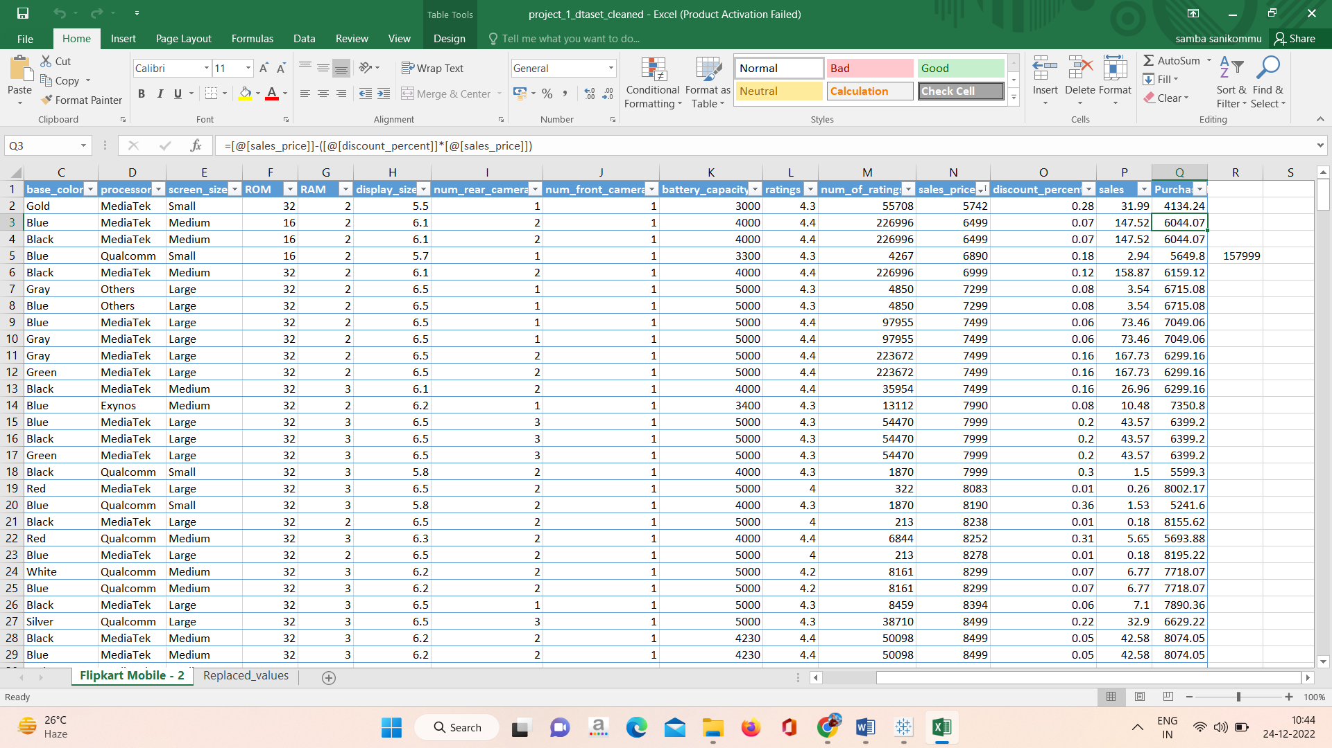

**Step 3: Data Interpretation**

In this step, we use different analytical methods to get a overall summary of the data we use. This will help us to summarize and manipulate the data and conclude it.

**Step 4: Data Visualizations**

This step was the final process in this project. The data in the dataset were used for visualizations and with those data we can able to create a dashboard which will show us detailed insights about the data.

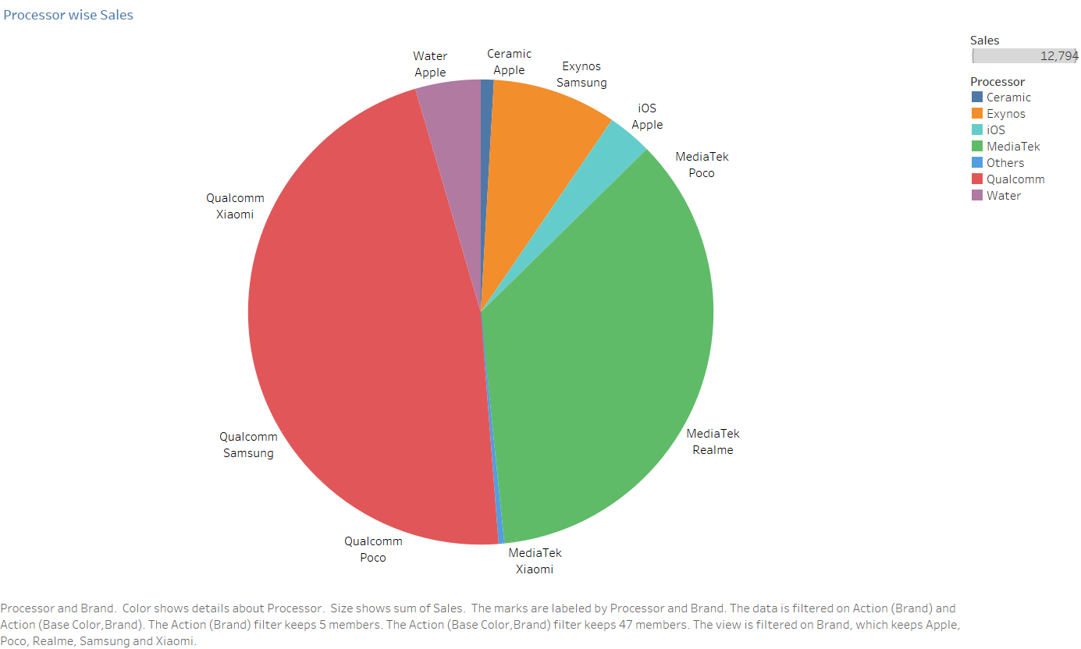

1. **Which brand mobile Buys mostly users**

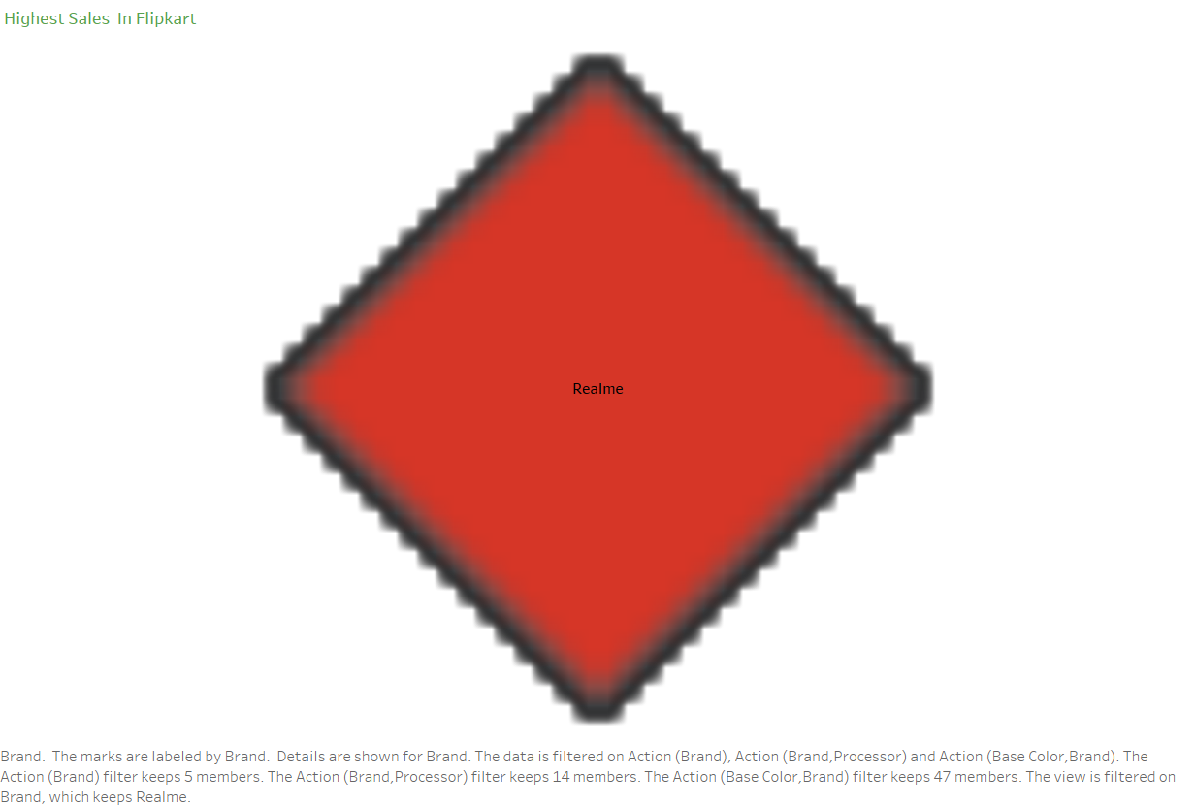

1. **Which brand mobile has highest cost**

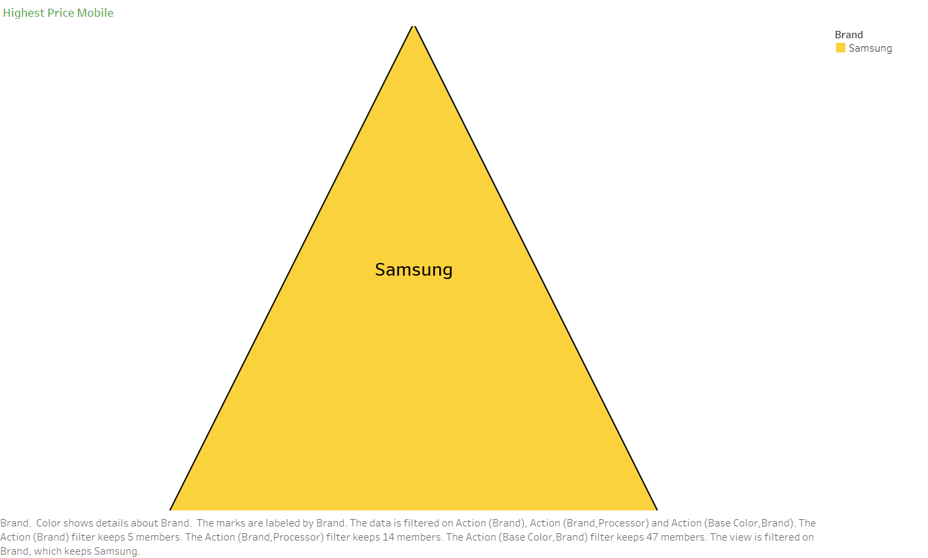

1. **The processor will effect on buying**



This plot shows the sales of different mobiles Processor and Sales. From this graph, we can see that Qualcomm is most bought by Customer. So People Must See While Buying Then Processor will effect on Buying.

1. **Which feature will impact on buying of mobile**

**Battery Capacity**

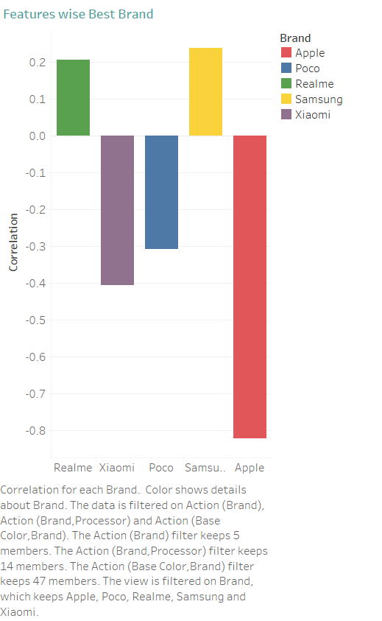

**Processor**

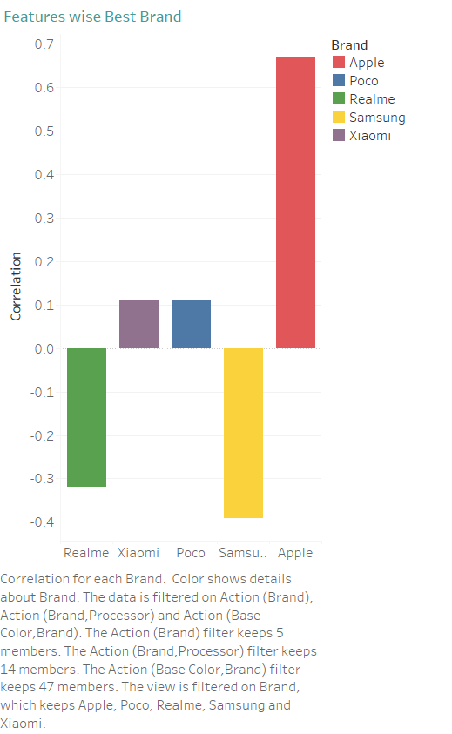

This plot shows the sales of different models of Mobile Correlation of Sales and Feature. From this graph, we can see that Processor and Battery Capacity Most effecting Parameters for Buying.

1. **Features impact on buying chart**

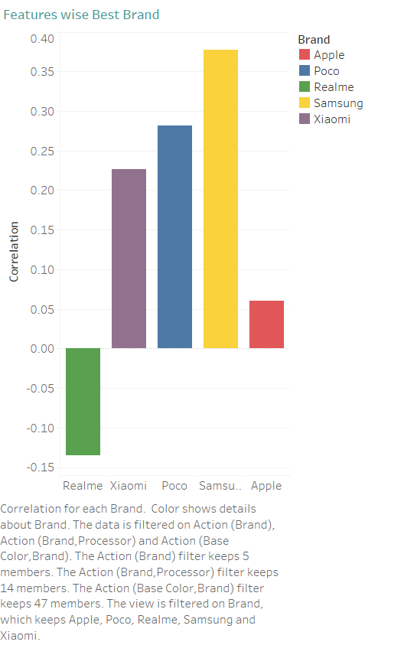

Screen Size Parameter Chart Shows above Chart. But RAM, ROM, Battery Capacity, Processor, Rear Camera, Front Cameras, Brand are also Effecting Parameters for Buying. Clearly Shown in .twbx file.

1. **Will rating impact on Buying**

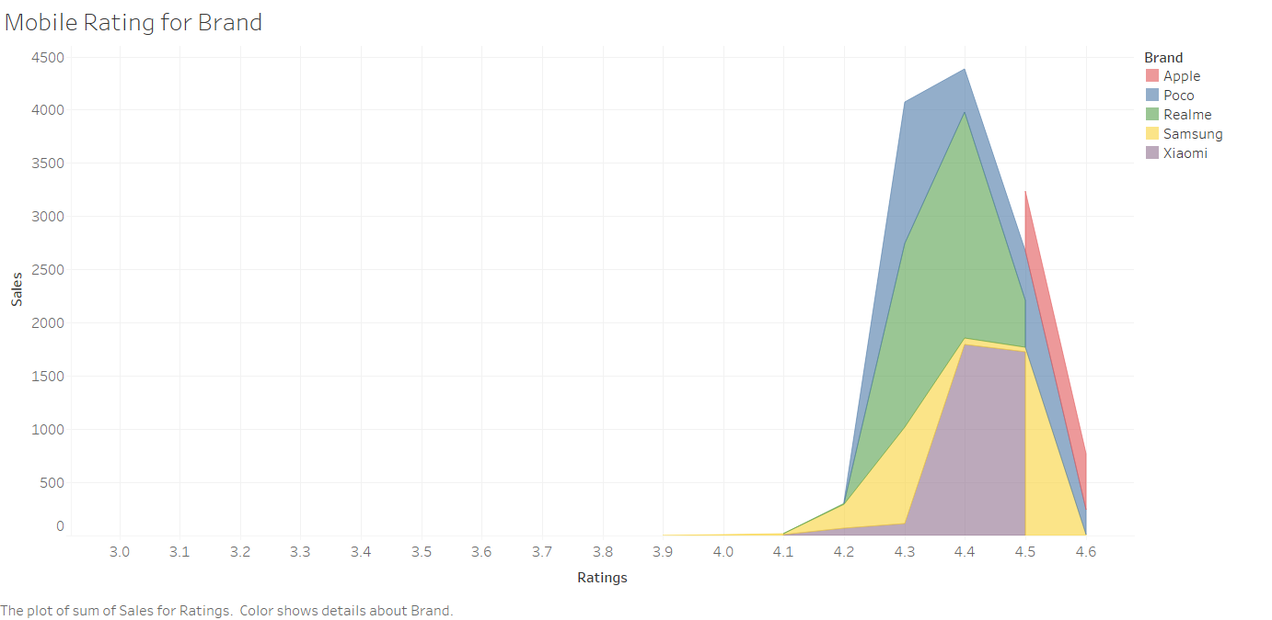

This plot shows the sales of Mobiles by different brands based on ratings. From the above graph, we can know that Any Brand of Mobiles Mostly Highest Sales occur at 4.4-4.6 Rating. So Rating Will also effect Buying.

1. **Customers uses which brand mobile mostly**



1. **Price after Discount**

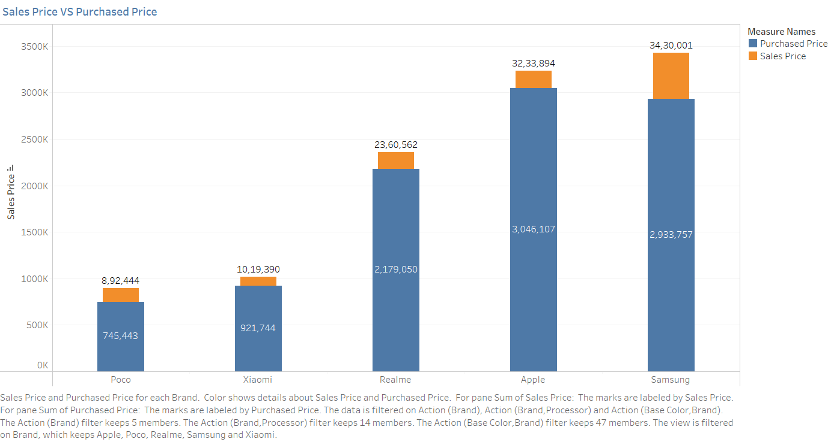

This plot shows Sales Price and Purchased Price (Price after Discount) of Customer of Each Brand.

1. **Mobiles for Poor Class People**

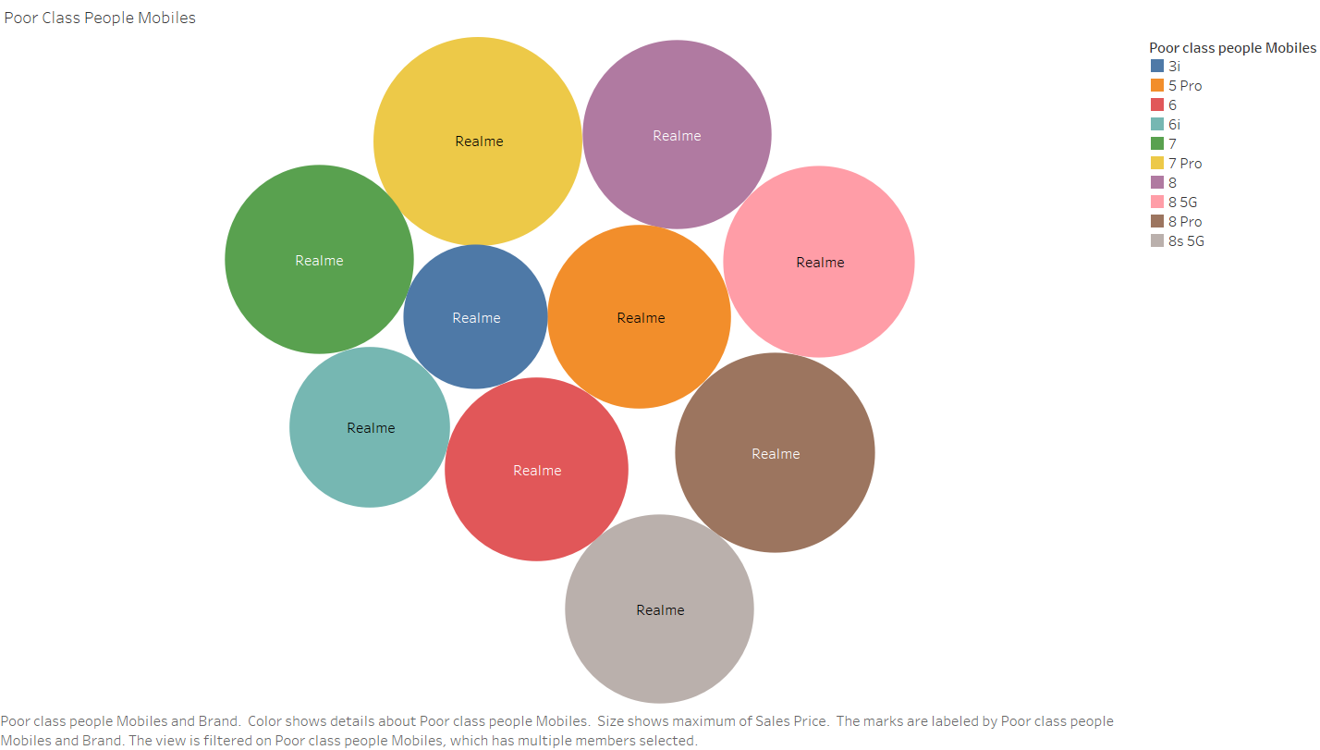

This plot shows Different Brand and Model of Mobiles for Poor Class People

1. **Mobiles for Middle Class People**

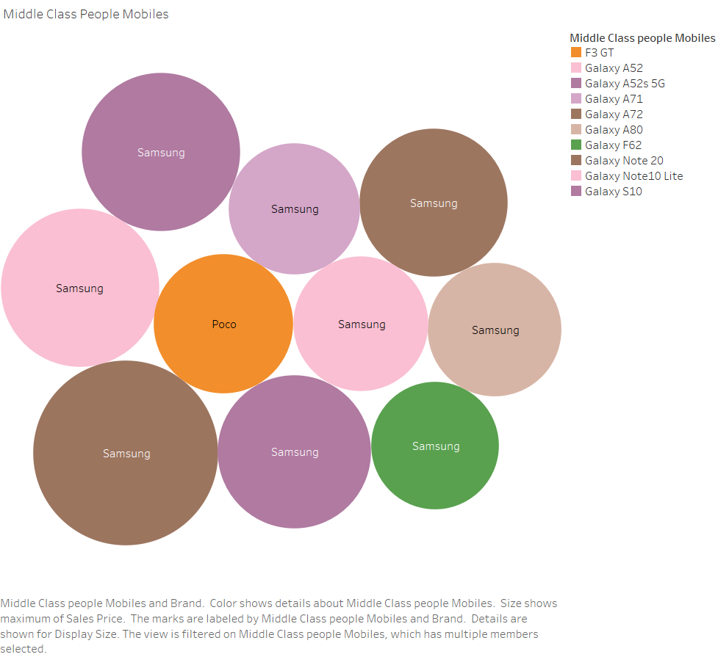

This plot shows the Suggestions for different Brand and Models for Middle Class People

1. **. Mobiles for Rich class people**

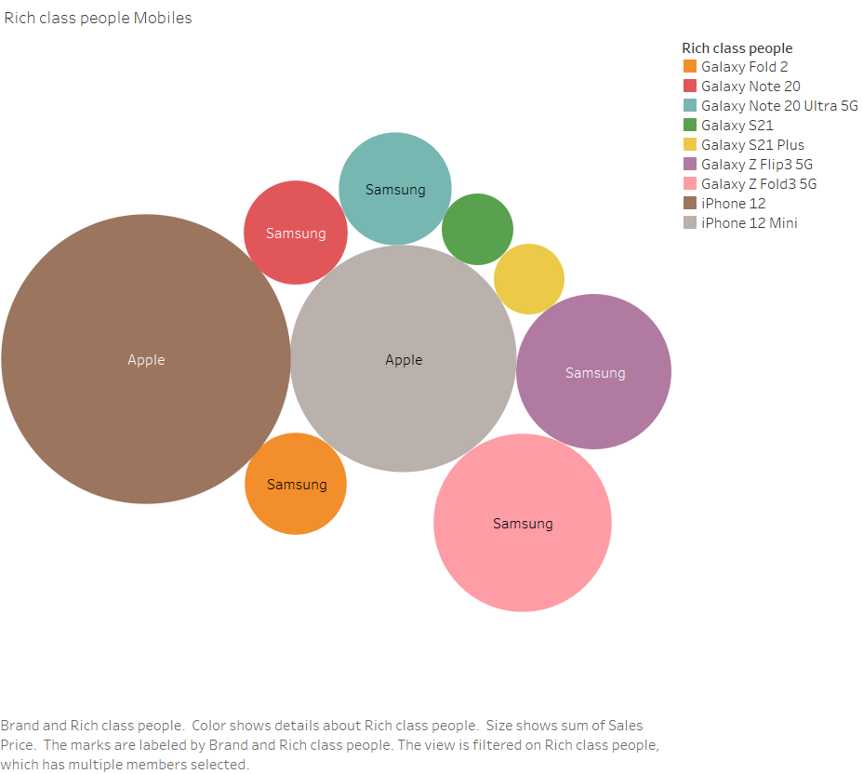

This plot shows the Suggestions for different Brand and Models for Middle Class People

1. **Which colour used mostly.**

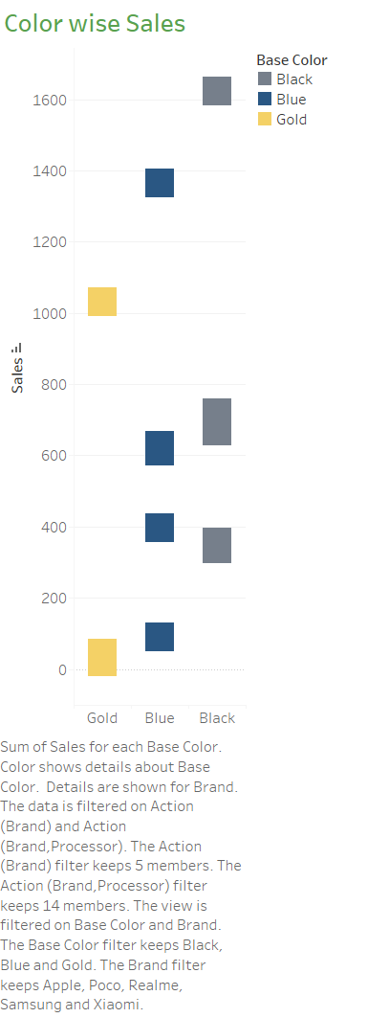

This plot shows the sales of Mobiles based on Colour. From the above graph, we can see that Most Sales are occur Based on Black colour Then Prefer Blue Colour.

**Observations:**

1. People Mostly Prefer Water and Qualcomm Processor Mobiles
2. People prefer Realme Brand Mobile with Media Tek Processor mostly.
3. People Mostly Concentrate on Brand, Processor, Battery Capacity, RAM, ROM While Buying
4. Ratings Plays Key role in Market Sales.
5. Mostly People Prefer Black Colour Then See Blue Colour Mobiles.

**Conclusion:**

1. We can conclude that Realme as more comfortable one since it has greater sales value than other Mobiles.
2. We can conclude that Realme, Apple, Samsung Mobiles in Blue Colour, Xiomi, Poco in Black Colour attract the People more than any other Company-Colour combination.
3. We can conclude that Realme with Media Tek, Xiomi, Poco with Qualcomm Processor attract the People more than any other Company-Colour combination.

**Recommendations:**

1. We can also find which company has sold most number of Mobile types which is most bought by the customers.
2. We can also Suggest the Mobiles for Poor Class, Middle Class, Rich Class People.
3. We can find Purchased Price, Sales Price For Mobiles.
4. We Can find Which Features will Prefer While Buying .

**References:**

**Flipkart Sales**

(<https://www.kaggle.com/datasets/shubhambathwal/flipkart-mobile-dataset?select=Flipkart+Mobile+-+2.csv>)